LAB 04
Start, Sleep and Stop methods of multithreading
OBJECTIVE:
Understanding concurrency by implementing start, sleep and stop thread functions.

Task: 1
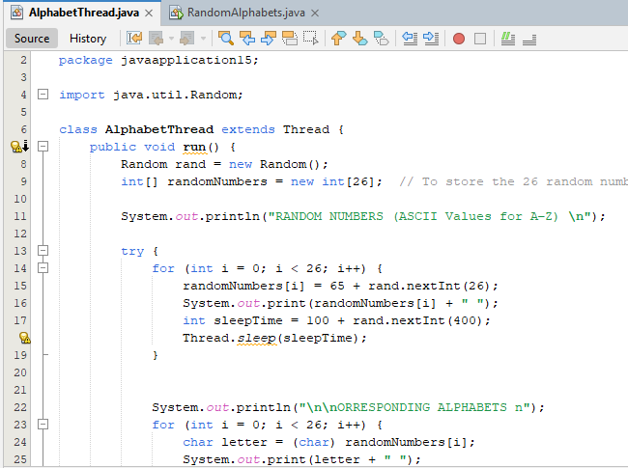
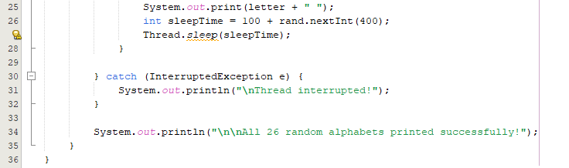
OUTPUT
